Massestrøm: 0.65*0.9705  
Ikke /2 i convective_heat_transfer_coeff:  
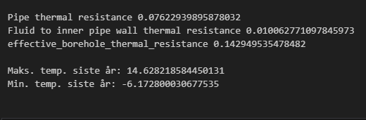

Massestrøm: 0.65*0.9705 * 2  
/2 i convective_heat_transfer_coeff:  
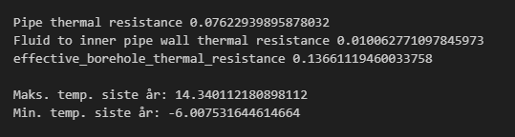

Massestrøm: 0.65*0.9705 * 2  
Ikke /2 i convective_heat_transfer_coeff:

